Protect Our Streams!
Report Illicit Discharges to Streams and Storm Sewers
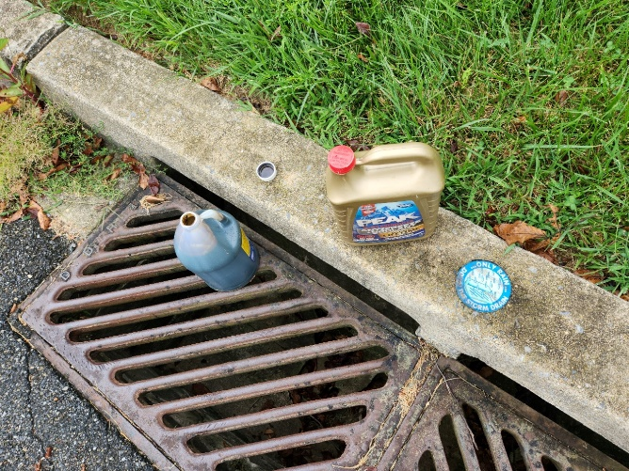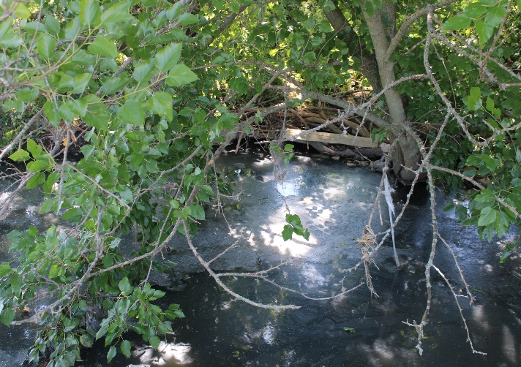
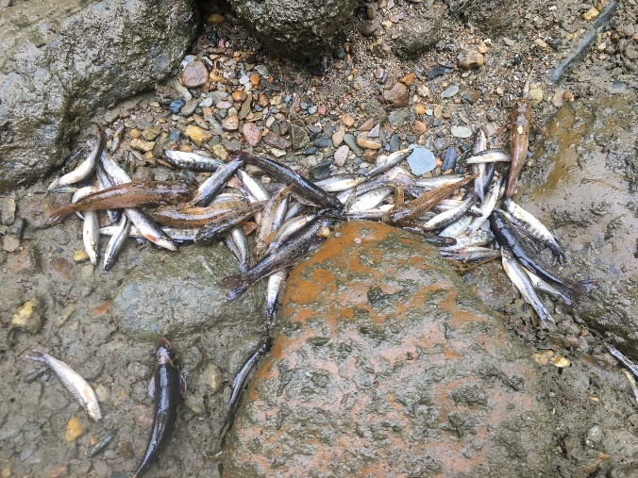
Signs of an illicit discharge:
- Oil, antifreeze and household chemicals dumped down a storm sewer
- Make-shift pipes or hoses coming from a home or business to a creek
- Foul-smelling and off-color streams and waterways
- Dead fish and other wildlife in a water body
These pollutants can be harmful to human health as well as for wildlife and water quality. Report any suspected illicit discharge to your municipality at (phone, email, website)

